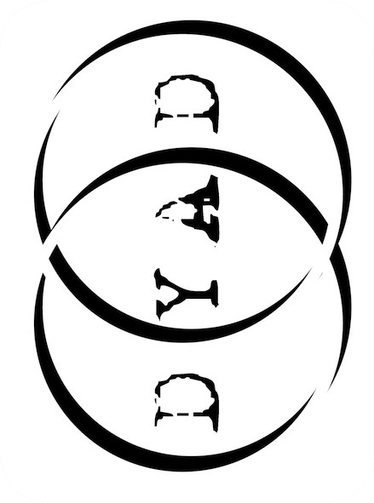 Dyad Productions

# Female Gothic

# PRESS RELEASE

A DYAD PRODUCTION

Adapted and performed by Rebecca Vaughan

Directed by Guy Masterson

From the company that brought you ‘*Austen’s Women’*, ‘*I, Elizabeth’* and ‘*The Diaries of Adam & Eve’…*

*An artist, gripped by the clutching fingers of a dead past; a scientist, defying nature in the dark realm of the senses; an expectant father driven mad by creeping shadows…*

In the unquiet, stygian darkness between life and death, a lone, haunted woman tells chilling tales of the macabre and uncanny, of love, loss, death and the darkness beyond, illuminating the curious frailties of human nature…

The Victorian fascination with tales of mystery and the supernatural created an enduring legacy of Gothic fiction; but it is often the male writers that we remember. Today, Charles Dickens, M R James, Edgar Allen Poe and Sheridan Le Fanu continue to be celebrated, yet many of the brilliant, evocative, thrilling and eerie ghost stories created by the great and incredibly popular female writers of that era – Mary Shelley, George Eliot, M E Braddon, Edith Wharton, Edith Nesbit et al – have gathered dust and been forgotten. Until now…

Dyad Productions creates, produces and tours classic theatre with an innovative and contemporary emphasis. This dark celebration of female gothic is their fourth original production in as many years. Previous works, *Austen’s Women* and *I, Elizabeth* were five-star successes at Edinburgh and Adelaide in 2009 and 2010, with *The Diaries of Adam and Eve* garnering five-star reviews at Edinburgh 2011. All three plays continue to tour across the UK and internationally.

*Female Gothic* is written and performed by Rebecca Vaughan (writer/actor: *Austen’s Women*, *I, Elizabeth;* actor: *The Diaries of Adam and Eve)* and continues the successful collaboration between Dyad and director Guy Masterson (Olivier Award-winning *Morecambe*, *Scaramouche Jones*). Costumes are provided by Kate Flanaghan (*I, Elizabeth*, *Austen’s Women, Bollywood* *Steps, The Diaries of Adam & Eve*), and the script editor is Dyad writer/actor Elton Townend Jones (*The Diaries of Adam & Eve, Cutting the Cord*).

★★★★★ ‘A macabre masterpiece. Ghostly, grisly, gorgeous. Don’t miss it. ’ (**Three Weeks**)

★★★★★ ‘A masterclass in storytelling. Chilling, haunting, dazzling. Brilliant. (**Hairline**)

★★★★★ ‘Injects life into your imagination. Exquisite… Brilliant. Beautiful.’ (**One4Review** )

★★★★★ ‘This is how horror ought to be done. It will chill your blood to the marrow’ (**The Carrick**)

★★★★ ‘Holds the audience in the palm of its hand. A near perfect piece of theatre.’ (**The Scotsman**)

★★★★ ‘Wonderfully eerie, and captures the real fear of the audience.’ (**British Theatre Guide**)

★★★★ ‘Suspenseful storytelling with a delicious tingle of horror.’ (**Broadway Baby**)

★★★★ ‘*Female Gothic* will have you captivated from start to finish (**informed Edinburgh**)

★★★★ ‘Thought provoking, delightfully creepy.’ (**Fringe Guru**)

★★★★ ‘Chilling… a beautifully constructed triumph.’ (**Scotsgay**)